Shimming the oil pump, 3mm, and a how-to with pics.........
Ok this procedure too me approximately 4 hours, however that included time to stop now and again to document it. So it should only take about 3 hours from start to finish.
If you don’t like doing general automotive maintenance such as oil changes, tune ups and general work as changing CV shafts, I will advise you that this is a procedure that can really screw up and engine if done wrong, so if you have any doubts about doing this (mechanically) then I say don’t. If you do however screw something up while doing this procedure, then see my sig.
All in all this procedure is very well worth doing. I am however not positive about how much my oil pressure increased as I do not have an aftermarket OPSU (oil pressure sending unit) and an aftermarket oil pressure gauge. However, my oil pressure did go up significantly according to the OEM OP gauge. Before doing the procedure my oil pressure ran right on the first line in the low end of the gauge (about ¼” from the red mark) and it only moved about the needles thickness increase oil pressure when revved to 3000 rpm. This really bothered me as I know how the #5 & #6 rod bearings like to starve for oil. Cold starts only saw oil pressures about ½ way between the “L” and the first low mark. All the while I was running 5w30 Syntec.
On a side note, my HLA tick was IMO pretty severe, it could be heard about 50ft from the car when warm, and I knew this was hurting performance and fuel mileage.
You will need an oil change, you don’t have to replace the filter, but why not you’ve gone this far. The oil pan gasket will be about $5 and can be bought at any parts store that carries Fel-Pro.
The Fel-Pro part # is: OS 30909 C
TOOLS NEEDED: : : : : : : : :
Jack, Jack stands, tire removal sockets and wrenches/locks, drain pan, oil/grease rags (several), 10mm socket, 12mm socket, 14mm socket, extension for ratchet being used 4” min., small/medium/large flat blade screwdriver, hammer, 10mm Alan wrench (must be regular style with 90* bend and 3” straight part or there about, not the socket kind, short piece of pipe (20”+) to fit over Alan wrench), Locktite 242 or higher, torque wrench, razor scraper, wire wheel, new oil pan gasket.
Now you will need a ruler, and a washer that is 1/8th inch, or 3-3.3mm in thickness. I had to use three (3) washers to achieve this thickness.
It is optional to remove the front part of the exhaust. The down pipes and collector. I chose not to.
This is a pic of the oil pump and pressure relief valve..
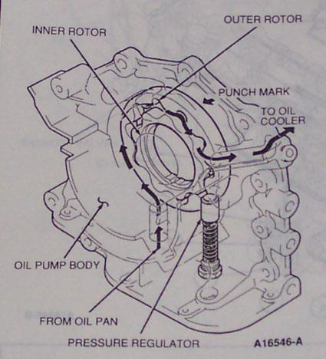
OK, enough of my rambling now for the Oil Pump shim procedure.
Step#1)
Jack the car up, support with jack stands. Remove R/F (right front) tire. Remove plastic splash shield on the passenger’s side of the car. Drain oil, but leave filter on as you don’t want oil dripping on you the entire time. 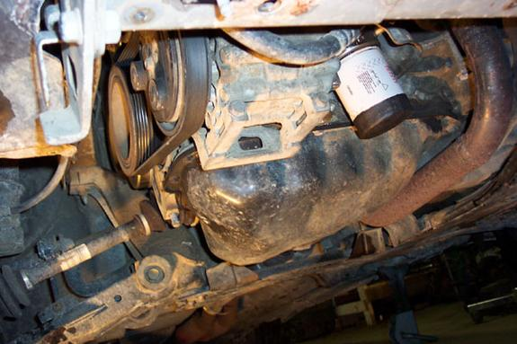
Step#2)
Now remove all of the oil pan bolts including the two that are nearest the flywheel. (If they turn hard, then easily turn them ¼ turn at a time, ¼ turn out, ¼ turn in, ½ turn out, ¼ turn in, etc… until all of the bolts are out.) As seen here:: (~Haynes book pic, hey it was good for something. :grin: ) 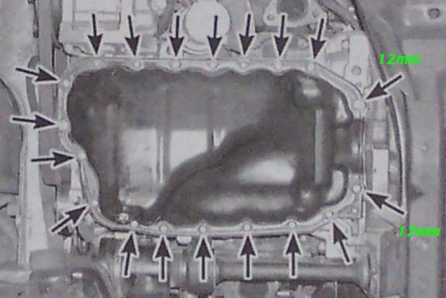
Step#3)
Take a 14mm (IIRC) wrench or socket and remove the rear most bell housing shield bolt. Optional to remove the other two and remove the shield, I chose to remove it as I wanted to see the flywheel and how much dust was on it. This must be done as the rear 12mm oil pan bolt will not clear the bell housing shield bolt. Shield bolts: 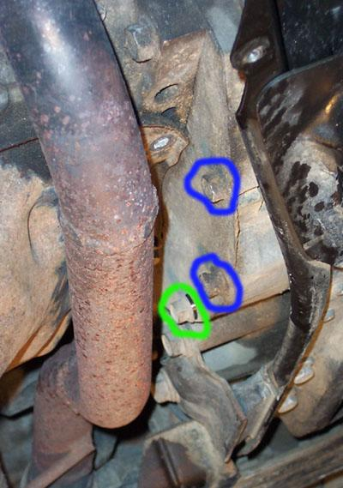

Oil pan bolts, 12mm.
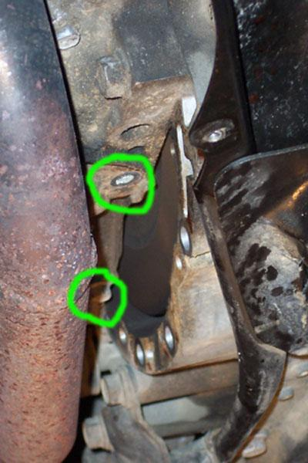

Step#4)
Now is the fun part. Take the smallest screwdriver and the hammer, drive it under the oil pan edge about ½-3/4 of an inch, then remove and repeat with the next largest screwdriver, repeat previous with large screwdriver. Once the largest screwdriver is under the cover, twist the screwdriver and break the gasket free, use a small screwdriver to aid in the gasket separation all the way around the pan. As seen here:
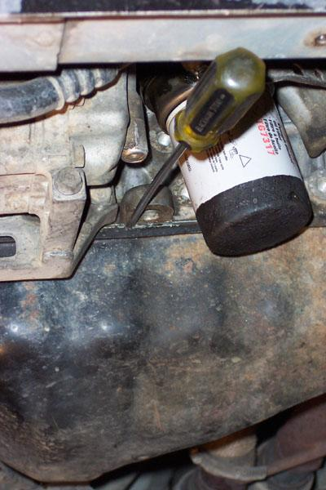
Aiding with the small screwdriver seen here.
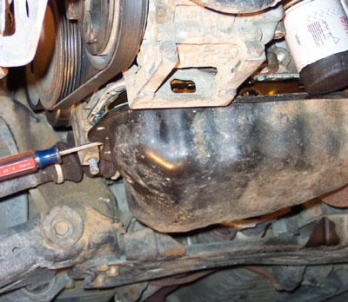
Step#5)
Remove the pan.
Step#6)
This is what you see, the internals of the engine, pickup screen and the dipstick.
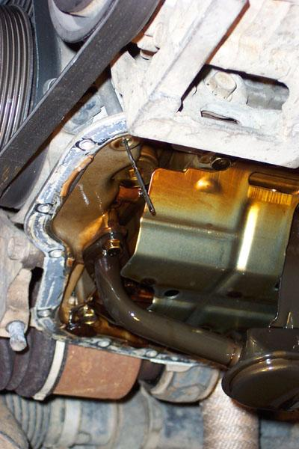
The oil relief valve is located above this Alan screw:: (circled in green)
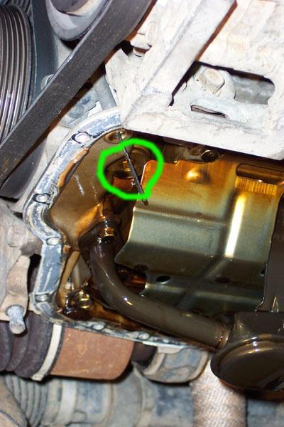
Step#7)
Use the 10mm Allen wrench and the short section of pipe to loosen the Allen screw that holds the relief valve in place. This is the reason why the R/F tire had to be removed, as you WILL have to use the pipe. Mine took A LOT of force to loosen; at first I thought that I had broken the Allen wrench. (Must turn toward rear of car to loosen) Seen here:
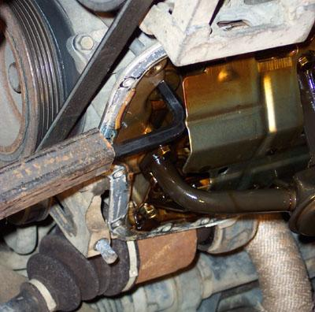
Step#8)
This is the oil relief valve when removed.
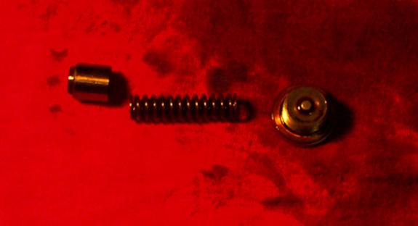
As it sits in the car.
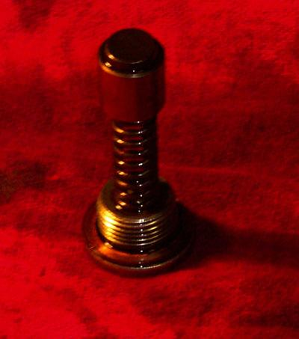
Step#9)
Now install the shims, between the Alan screw and the spring.
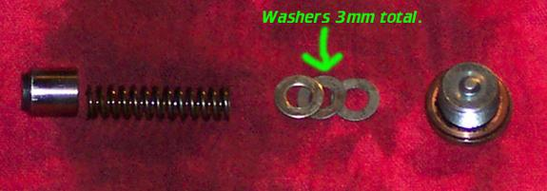
Note in this pic that the stepped end is facing up, as it goes into the engine first.
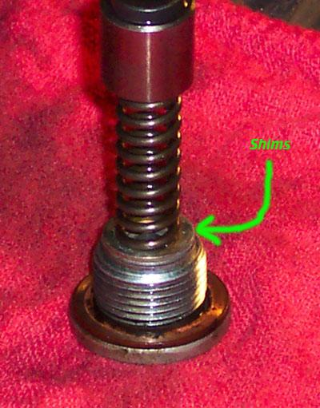
The thickness of the shims I used….
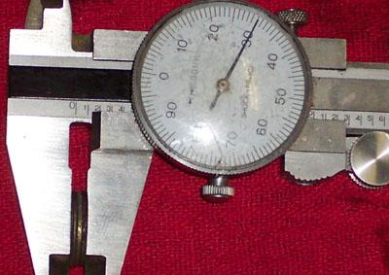
Step#10)
Apply some Locktite to the threads of the Allen screw and reinstall the relief valve. The valve and casing are machined to be a tight fit so they must be lined up perfectly straight to go back together. Once threaded into place tighten. (I looked for several minuets and couldn’t find a torque spec for the Allen screw so I just tightened to what I considered a tight spec, thus the reason for using the Locktite.)
Step#11)
Clean the oil pan gasket surfaces, both oil pan and block sides, with a razor scraper first then with a wire wheel, to ensure a good gasket seal. Make sure all of the old gasket material is out of the pan, off of the mating surface and that there are no foreign objects in the engine/oil pan.
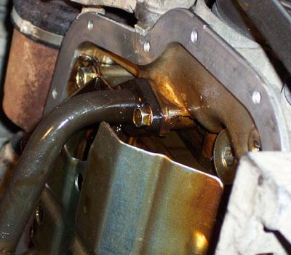
Step#12)
Get the gasket out. (Optional, spray both sides with copper spray and let set)
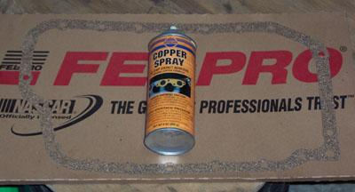
Slide oil pan into place and start all the oil pan bolts, make sure that the gasket is between the pan and the block when you start the bolts. I started at one end and worked my way around the pan and just started the bolts, not tightening them down or even snugging them. After all the bolts are in and the gasket is aligned properly snug the bolts down and then tighten them down to the following specs:
Long bolts (12mm IIRC) 14-18 lbs
Short bolts (10mm) 71-88 in-lbs
After tightening the bolts down (criss-cross tightening fashion, starting in the center and working your way out) go back and double or even triple check the bolts.
Step#13)
Remove the oil filter and let drain, reinstall new filter. Reinstall drain plug in pan, tighten, and fill engine with oil. Check oil level.
Step#14)
STOP!!!!!
Before starting you need to prime the oiling system, as you don’t want to start the engine while all the oil passages are empty of oil.
Open hood, if not already, remove the fuel pump fuse from the engine fuse block. Seen here…circled in green, to the left, it is pink:
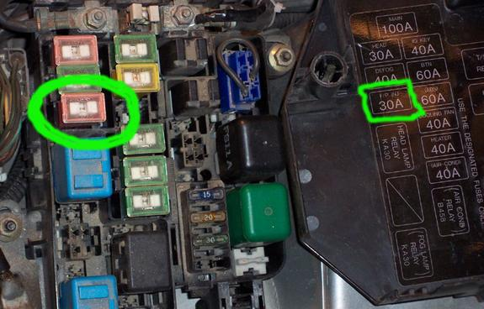
Now get in car and crank it over until oil pressure is achieved, may take up to 15 sec or so. Reinstall the fuel pump fuse and double check for oil leaks. Also check the oil level via the dipstick. Also, if you removed the front part of your exhaust, you might want to reinstall it now.
Step #15)
Now is the fun part! Start the car. Immediately get out and look under car for leaks, let it run until it reaches operating temp, the entire time checking for leaks. If there are none congratulations, you’re done!!! Almost… reinstall the R/F tire and lower the car off of the jack stands.
Double check the oil level for the first couple days to make sure it is at the proper level.
In the results following the procedure, I found that it isn’t a good idea to initially think that it did little good, but it is better to wait for a few miles and then check the pressure difference as it will change slightly upon running the engine a few miles.
My cold start pressure (OEM OPSU and gauge) now reads between the “R” and the “M” and at idle once warm it runs about the needles thickness below the “L”. Wooooo Hoooooooo.!!!!!!!!!!!!!!!!!! My cold starts were half way between the “L” and the first low mark, as stated above, and when warm it was right on the low mark.
Also, as side noted above, this silenced my HLA’s completely. Except for some slight tick upon cold startup and a second or so upon warm startup.
Enjoy!!!
~Silver

