Credit goes to probetalk.com member “leska” for this write-up. I (“ely 626 v6) just copied and pasted.

Due to the knocking noise and slow leaking of antifreeze, I decided to bite the bullet and replace the timing belt, tensioner arm and water pump.
The following is information and photos regarding the repair procedure as well as replacing idler bearings for the timing belt and accessory belts.
TIMING BELT
(Loosen Crank / Water Pump Bolts)
Before jacking the car up, MTX and ATX PGT’s should turn their wheel to the left and pop out the rubber plug in the splash well. The crank bolt is accessible directly inline with this hole pictured here………
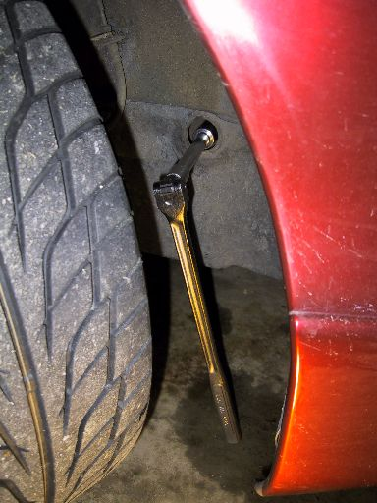
Put the MTX in forth gear and set the parking brake firmly. The bolt can easily be broken loose with a breaker bar.
ATX trannys will have to brace the breaker bar against the frame rail and tap the starter to crank the engine and pop the bolt loose.
Next, while the car is still on the ground with all the belts still on, take a 10 mm combination wrench and crack the four water pump pulley bolts loose. It’s much easier now with the driveline and belts holding the pulley(s) still.
(Removing the A/C and Alternator belt)
This belt is tensioned with a pulley that is forced down via long bolt and thread. You must unloosen the 17mm locknut on the pulley and then you can turn the 10mm adjustment bolt counterclockwise to raise the pulley wheel off the belt. Once the pulley is fully loose, remove the locknut as well as the pulley itself. By the way, the lock nut is somewhat difficult to access. I use a 1” combination wrench turned sideways over the end of the 17mm wrench or leverage. This can be pictured here…...
(Unplug Wires)
Behind the coolant cap on the passenger side is two coolant-related sensors that pass over the belt area. There is also the Crankshaft Position Sensor connector right under the radiator hose. Disconnecting these is not required, but it certainly makes it easier. Push them out of the way once disconnected. The ford manual recommends removing the upper radiator hose, but this really isn’t necessary.
(Optional: Remove Spark Plugs)
This is not a requirement to do the belt. However, the engine will rotate freely without plugs installed and no compression. This is very nice for turning the crank and cams by hand later on for alignment.

(Raise and Support the Vehicle)
(Remove the lower splash)
The lower right engine splash shield must be removed. There are assortments of bolts and snap clips used to hold it on. Remember to push the center of the plastic rivets in to unlock them before attempting to remove them. The center must be pushed out past the rivet surface to reset them for installation. My PGT had both 10mm and one 8mm bolt holding the shield on The shield and bolt holes can be seen here……
(Remove Power Steering Belt and adjuster)
Once the Splash Shield is removed, you will have easy access to the other belt adjuster. As before, crack the 17mm nut loose and turn the 10mm adjuster until the belt is loose. Remove the locknut and pulley completely. Remove the belts as well. This can be seen here……
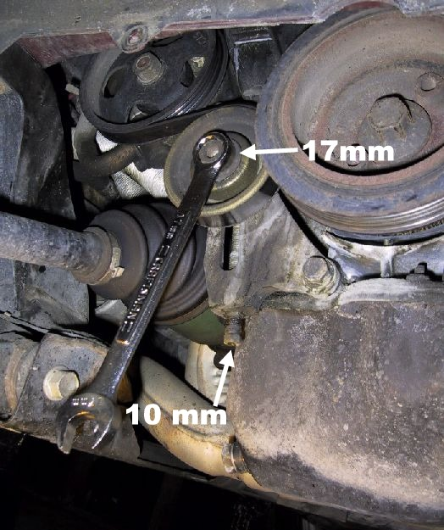
(Remove Crank Bolt and Pulley)
Now that the belts are removed and pressure is off the crank, remove the crank pulley bolt and wobble the balancer/pulley back and forth until it loosens up and slides off. In some cases, the pulley will need to be carefully pried off with tools. If necessary, place suitable pry bars behind each side of the pulley and force it off. Be careful not to damage other parts or the crank position sensor. Sometimes its helpful to smack the lip of the crank pulley a few times with a rubber or rawhide mallet to break it loose. The pulley is keyed to the crankshaft and gets rusted on. The parts can be seen here……
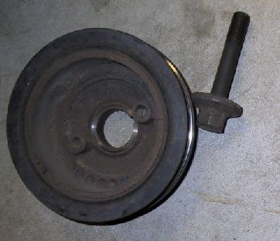
(Remove the Water Pump Pulley)
At this point, if you’ve followed my instructions, you should see this….. 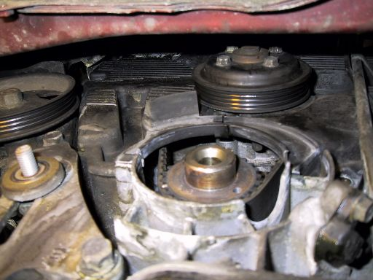
And the bolts can be removed with your fingers Remove the pulley.
(Optional: Remove Power Steering Pulley)
This is not a requirement, but it makes getting the timing covers off much easier. A suitable bar can be inserted in the spaces within the pulley to hold it while turning the locknut. I’ve now done this job both ways. Next time I’ll take this pulley off again.
(Remove Cover/Bracket Bolts)
The timing cover 10mm bolts can now be removed from the lower end of the covers. There are two bolts on the outside of the left cover, two bolts on the right outside (one has the Crank Sensor Wire Support), one directly above the crankshaft.
Remove the bolt that supports the oil dipstick tube and remove the tube by pulling upward carefully to dislodge the “O” ring without damaging it. Plug the hole in the block to prevent dirt from falling into the oil pan.
Now remove the upper accessory belt support bracket. There are two bolts that hold the bracket in…..one long bolt on the top and a short one in the bottom. It looks like this……
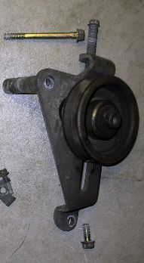
Next, remove the upper cover 10mm bolts. There are three around each cam sprocket (be prepared to fight for the bolt on the bottom rear edge of the rear cam ), one in the “V” of the block and another on the rear (left) cover in a similar place as the oil tube bolt on the right cover. Remove the covers. All these bolt locations can be seen here……
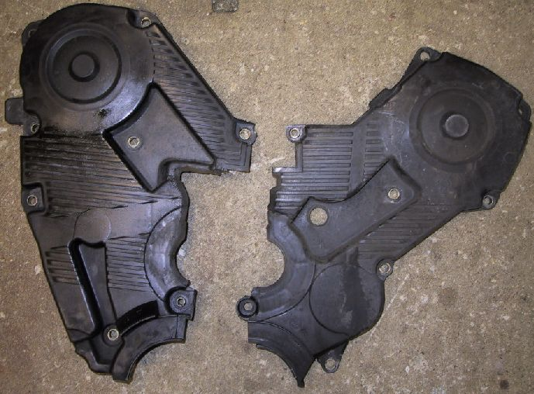
(Remove Engine Mount)
Remove the three 17mm nuts on the engine mount. There is a ground wire clamped between two of the nuts. The engine will fall slightly as the mount is loosened. However, the engine will not fall down due to a tab on the support bracket. I like to put a 2x6 under the oil pan and tranny and support the engine with a jack anyway. Just keeps stress off of other parts Remove the 17mm pinch bolt that connects the center of the mount to the body. It has a tab on the nut that keeps it from turning, so just loosen the front side. Remove the mount.
Next, remove the engine side of the mount which is the support bracket. There are three bolts that attach this to the block. This can be seen here…..
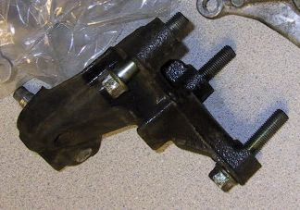
(Align Crank and Cams)
If you are just replacing the belt, turn the engine (put it in neutral by the way ) clockwise by the front cam sprocket center bolt with a 17mm wrench or socket. If you removed the spark plugs, this is very easy. If not, too bad for you Turn the engine until both the cam and crank marks line up. For those of you who are new to engine work, remember this will only happen every two rotations of the crankshaft.
For those replacing a broken belt, the PGT is a non-interference motor. The pistons will not collide with the valves when turning independently…..especially by hand. Align the marks as stated below.
The crankshaft marks are a triangle shape at 12 o’clock on the engine block and a “U” shaped notch on the sprocket. Note this picture has the crank turned slightly as required for install. These can be seen here…..
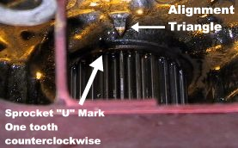
and here………….
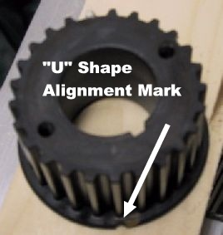
The cams are aligned by via a triangle shaped mark on the cylinder head and a circle punched into the cam sprocket that usually has colored paint on it.
Although the pictures are blurry ….sorry….but I’m not taking it apart again for more pictures …..you can see them here….. 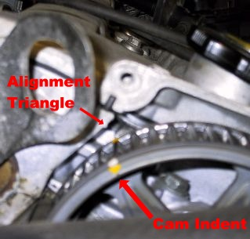

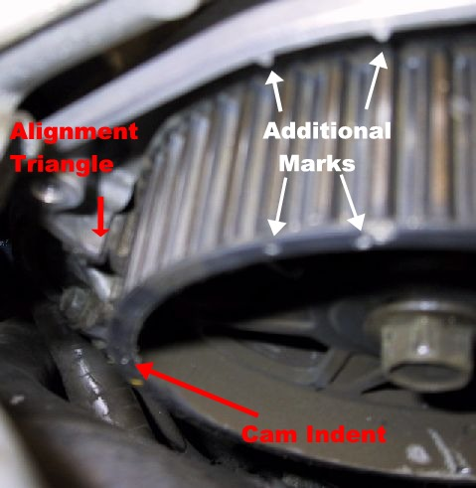
(Timing Belt Hydraulic Tensioner Arm Removal)
This is the infamous part that fails and allows a knocking noise to happen. There are two bolts that hold the tensioner arm in place. Take the bottom one out first. Once removed, THROW IT IN THE GARBAGE and replace it with a new one (try www.fordpartsonline.com or contact Travis Williams). Although it is very expensive, it doesn’t make sense to reuse this if it has any substantial miles on it. If for some odd reason you are removing a newer part, compress the post back into the arm with a press of vice very slowly and straight. Hold the post in place in the LOWER of the two holes with a drill bit or larger sewing needle. It looks like this…….notice the grease and dirt on the old one for those of you that heard my MP3 of the knocking noise……..
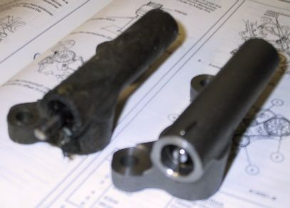

Remove the belt. If you are reinstalling the same belt, be sure to mark the direction it was installed. Never install a used belt backward. The fibers tear inside the belt.
By the way, for those of you who want to know what makes that terrible knocking noise, it’s the tensioner pulley hitting the rear metal timing belt cover seen here…….
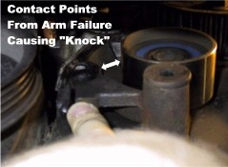
DETOUR!
WATER PUMP REPLACEMENT
If your PGT has some miles on it, consider replacing the water pump when doing the timing belt. I got my new (not rebuilt) Motorcraft water pump for $67 locally with a lifetime warranty. Note that there are two styles of pumps on the PGT….ones with a 32 mm pilot for the pulley and others with a 16mm pilot. Before purchasing the part, simply look in your engine compartment at the pulley to verify which one you have. The pilot stick out through the pulley. The timing belt does not have to be removed to swap a water pump, but it can be tricky fitting the pump in without messing up the new seal while avoiding the timing belt parts.
(Drain Coolant)
Remove both coolant caps. Place a pan under the drain valve and loosen the plug seen here………..
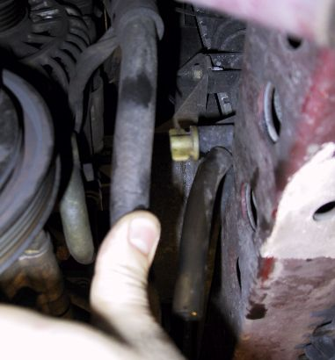
(Remove Pump)
Remove the 5 remaining pump bolts and remove the pump. Make sure all the rubber “O” ring seal came off with the pump. Both parts look like this………..
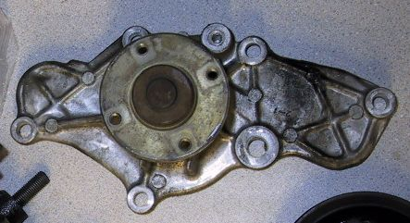

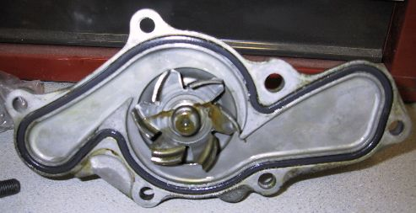
(Clean Mounting Surface)
Clean the pump mounting surface on the engine to remove corrosion which looks like this…..
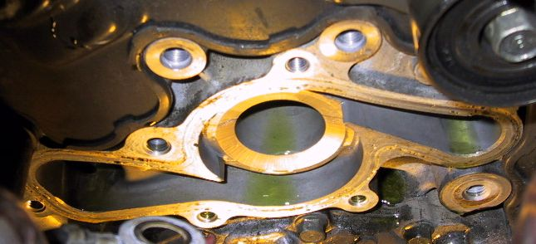
I prefer to use a mild 3M scotch-brite pad and then follow with a 600 grit aluminum oxide paper for a smooth finish and good seal. I use brake cleaner to remove all residue.
(Install Pump)
Place new “O” ring on the new pump and carefully position pump on engine. Although some like to use Silicone Sealant, I don’t like to use it on rubber “O” ring seals. Every other gasket is great with permatex, but not O-rings. I’ve seen many leak that were encased in silicone sealant. It’s a bit tricky getting the pump in place without dropping the seal, but we do this for the sport as well as the glory, right?
Install the 5 bolts (remember the engine mount takes up one hole) and tighten to 14-18 LB-FT
Refill cooling system once the car is level on the ground again. Remember to fill by the cap on the engine, not the expansion tank near the battery. You will have air trapped otherwise.
DETOUR AGAIN!!!!!
BEARING REPLACEMENT
If you’re like me and love a quiet smooth engine, you’d probably like to replace bearings when at all possible if they were cheap, right? Well here you go. I replaced all the bearings in the timing belt idlers and the car sounds fantastic just like new with 138K on it.
(The facts)
Each idler has 4 parts to it……a core piece, TWO bearings and the outer shell. The idlers are in the $160 dollar range each from Ford or Mazda. The bearing themselves have the number NSK 6006DWA on them. The 6006 bearing is very common, but not the DWA distinction. In fact, no one (even NSK reps) had ever seen a DWA on a bearing. I finally got a guy to call NSK Japan office. They found it was a special seal design for automotive use with 40% less seal drag, and of course you can’t buy them.
So what now? Here is my solution that works well. The factory idlers have two bearings pressed face to face with the inner seals removed (less drag I would imagine). I decided to use a standard 6006 on the outside bearing and a “no contact” type 6006 on the rear. My theory is the rear of the idlers were very clean and not easily covered with dust……..and 100% seal drag + 0% seal drag puts me 10% better than OEM. I pried off the inner seals like the factory did before pressing them back in. Each standard 6006 was $16 and the “no contact” 6006 was $12. They look like this……..
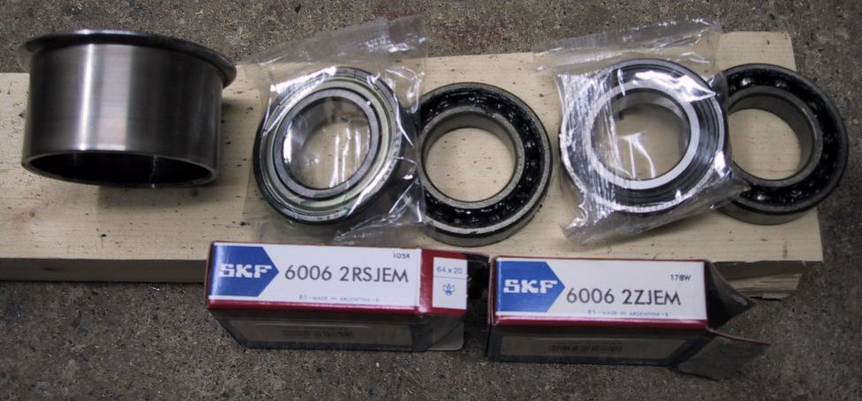

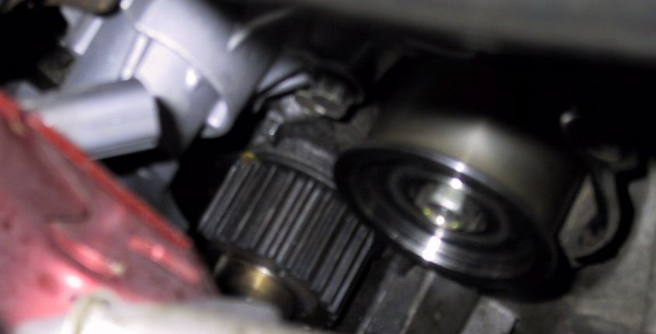

(Bearing replacement)
You have to be creative here if you don’t own a press. I used a variety of wood blocks and sockets to drive out the core and then the bearings. I braced the flanged part of the shell on four pieces of plywood while pounding out the bearings. Use a wood block and sledge to drive the bearings back in by the outside shell (to protect them). Make sure to pry off the inner seals before installing them. Lube the surface of the bearing with something light like liquid wrench to make pushing them in easier. This is really the best money ever spent on my car.
Why stop there? I asked myself the same thing. Why not do the accessory belt tensioner pulley bearings as well? These are infinitely more easy to pop out and press in with a socket. Replacements were $4 each. Once again they had a special seal marking for lower drag, but the standard bearing of that size had almost the same measured drag. Both pulleys use the same bearing. Looks like this……..
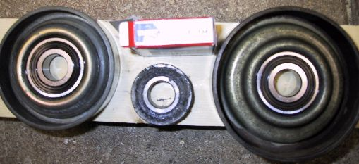
BACK TO TIMING BELT!!!!
TIMING BELT INSTALL
Verify crank and cam marks are aligned as stated above.
Rotate the crankshaft counterclockwise one tooth like this…………….
(Install Belt)
When installing the new belt, make sure that you can read the writing on the belt from the passenger wheel (not upside-down). Some manufactures optimize the tooth alignment for noise reduction. Slide the belt on while making sure not to rotate anything. Then turn the crank forward one tooth(match the alignment marks) without moving the cams to put all the belt slack on the tensioner side of the crank.
(Install Tensioner Arm)
Tighten bolts to 14-18 LB-FT and remove the pin holding the pushrod. Check timing belt tensioner pulley bolt for 28-32 LB-FT
(Verify Alignment)
Turn crank two turns clockwise and verify all marks line up and that the crank triangle and “U” notch now align vertically.
(Install Mount Bracket)
Install the engine side of the mount (bracket) with it’s three bolts and tighten to 32-44 LB-FT
(Install Covers/Bracket)
Install the plastic timing covers and tighten all 10mm bolts to 71-88 LB-IN (NOTICE INCH POUNDS!). Remember to remove the plug and install the oil tube with the middle right bolt and the Crank Position Sensor Wire Bracket with the lower right bolt. Install the upper belt tensioner bracket with it’s 2 bolts. Tighten them to 14-18 LB-FT
(Install Pulleys)
Install the water pump pulley and snug up the bolts. Tighten them to 71-88 LB-IN once the car is completed and back on the ground.
Install the Power Steering Pulley if removed and tighten to 36-43 LB-FT
Install the Crank Pulley and snug the bolt until the car is back on the ground. Tighten the crank bolt to 116-122 LB-FT
(Install Accessory Belts and Pulleys)
Install the pulleys on the adjusters, install the belts and turn the 10mm adjusters until the belts are tensioned. Remember, you can always tighten them more later. Pull or push on the center of the belts and see if you can flex them with moderate pressure about ¼”. Tighten the 17mm locknuts.
(Install Splash Shield)
(Install Engine Mount)
Make sure to attach the ground wire between the two left nuts. Tighten nuts to 54-76 LB-FT
Tighten pinch bolt to 50-68 LB-FT
(Install Electrical)
Reconnect Coolant Sensors and Crank Position Sensor Connector. Install spark plugs and wires if removed.
(Fill Coolant)
Check for leaks.
ENJOY!
Done. I’m going to pass out now
__________________
"Come on guy's, it's all ball bearings now. Maybe you need a refresher course." - Fletch
Last edited by leska on February 1st, 2002 at 11:03 AM

