HLA’s, what are they, why do they tick, how to clean them, disassembly/reassembly... (By SilverBullit on PT)
First disassembly...
DISSASSEMBLY:
1)The basic HLA. And pusher/lifter housing…
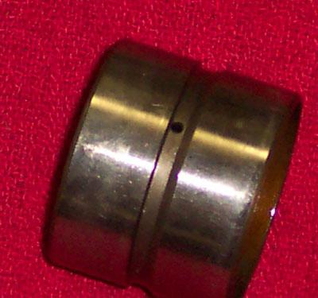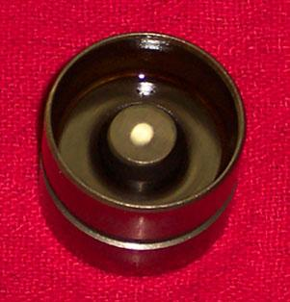

2) Pull the HLA out of the lifter housing. As seen here using a pair of robogrip pliers.
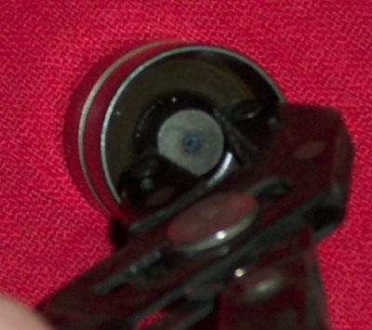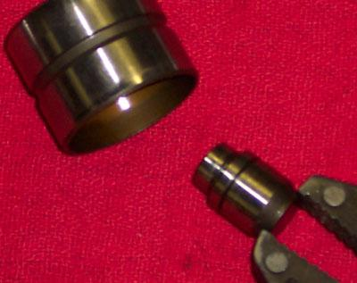

3) One little clip ring holds the HLA into its housing, seen here.
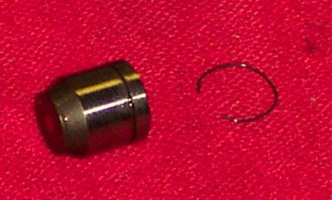

4) Pull the two (2) halves of the HLA apart.
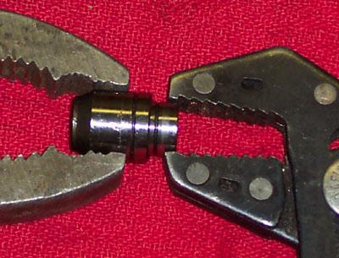
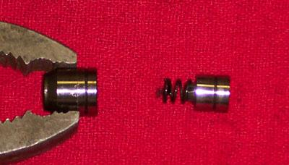

5) Now you have the small half and large half of the HLA, along with the larger spring.
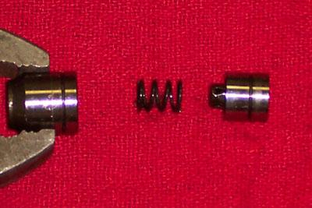

6)Pull the ball keeper off of the end of the small half of the HLA.
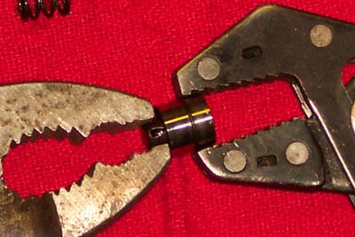

7) The result of #6, the spring in the background is the larger spring. There is also a very small spring that presses against the ball; it is located inside of the keeper, as seen in this pic...
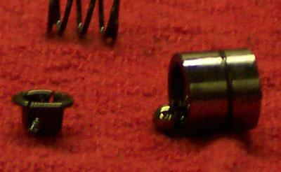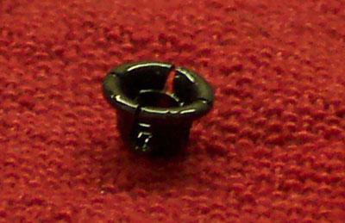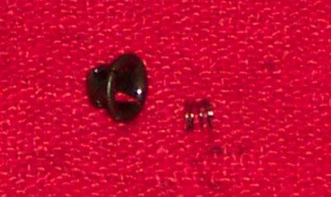

8)The smaller half of the HLA and the oil ball.
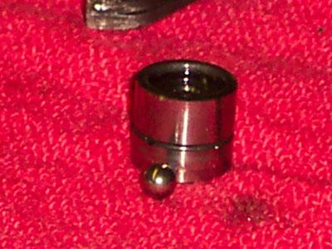

There the HLA is now completely disassembled, wasn't so hard was it.
Now the fun part:
REASSEMLY:
Do not put any oil in the HLA while it is apart, let them soak in a can of oil overnight and fully compress them the next day before installation.
Fully dismantled...
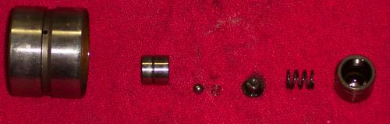

1)Put the ball into the shallow end of the smaller of the two halves of the HLA
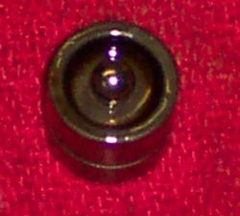
2) (Put the VERY small spring inside of the keeper) (kind of blurry, sorry).
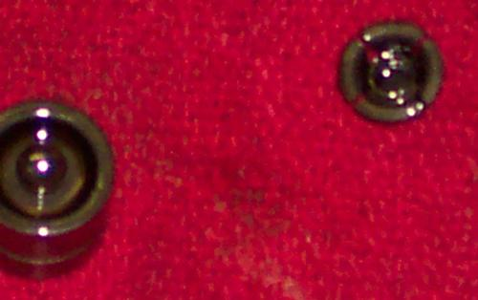

3) (Put the "keeper" with the spring inside of it onto the end of the smaller half of the HLA, make sure that the spring is against the ball and that it is pushed all the way into place).
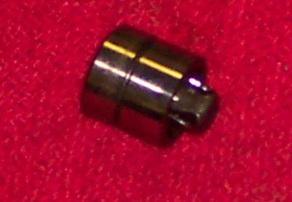

4) (Now place the larger spring into the end of the larger half of the HLA, make sure that it is straight).
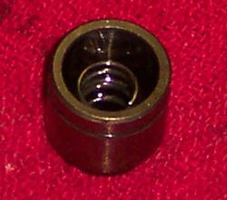

5) (Assemble the two halves of the HLA so that the large spring and "keeper" are touching one another. Also, make sure that the deep end of the small 1/2 of the HLA is facing out/up.
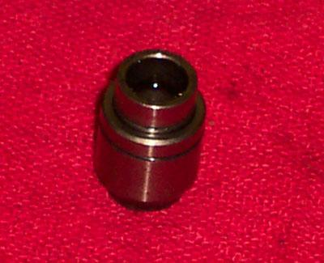

Top shot.
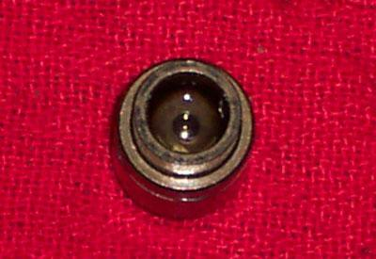

6) (Use a small needle or pin to push the ball down so that the internal pressure can be relieved so that the HLA can be compressed fully, compress it fully and pull the pin/needle out).
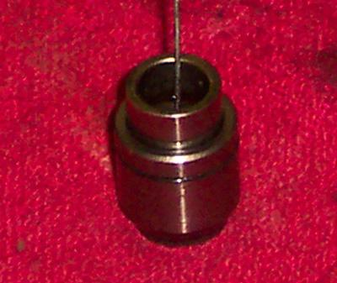

7) (Reassemble the HLA and "pusher", "lifter"... Put the end of the HLA that has the opening in it into the pusher/lifter first).
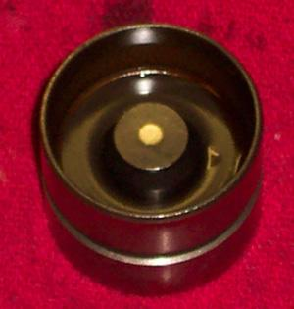

A theory of mine about the HLA and their ticking:
The internal oil pressure CAN'T be higher than the valve spring rating (i.e. 80 psi spring, 80+ psi oil pressure), for one thing our engines don't run oil pressure in that range. Next, if they did then the valve would never fully close due to the fact that the HLA would never partially compress.
My thoughts on the subject now lead me to believe that the HLA gets about 1/2 maybe 2/3 of the internal pressure of the valve spring. (e.g. 80 psi spring, the HLA has an internal pressure of maybe 40-65 psi or so) Due to this, the HLA compresses slightly when the cam turns, but the hole in the HLA is small enough so that the oil pressure can't bleed off fast enough and the valve opens due to the sudden spike in internal pressure.
Any other thoughts are welcome. More Pics are available.

